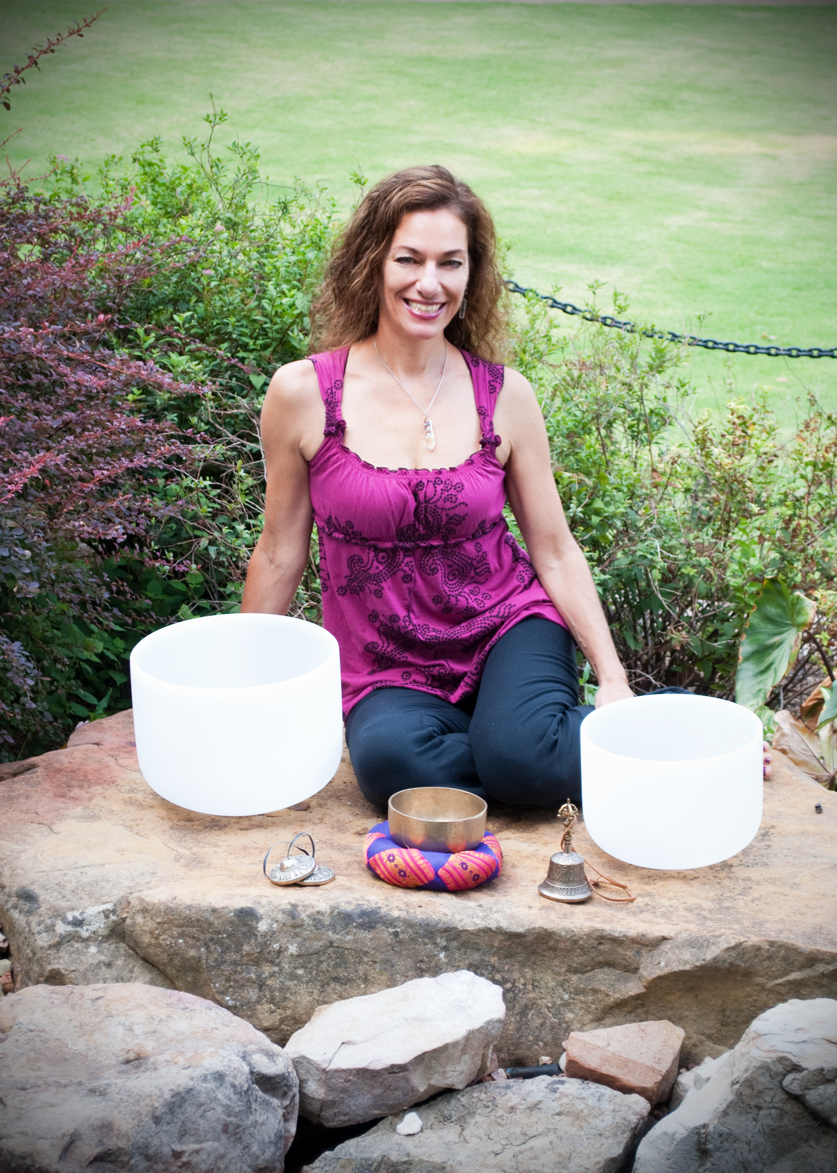
About Rica:
Rica Potenz is a licensed Massage Therapist, Reiki Master, musician and yoga instructor, and her practice includes many types of massage, CranioSacral Therapy, Lymphatic Drainage Therapy, Neuro Integration, ThetaHealing™, Reiki, Jin Shin Jyutsu, Dream Interpretation, as well as Sound Therapy using tuning forks and crystal bowls. Her desire is to integrate body, mind and spirit and assist others on their self-healing journey. Her healing studio is in Lewisville and she can be reached at potenzr@gmail.com or 972-333-4488. Website: ricapotenz.com

Sound is a powerful way to Open and Cleanse your Chakras. Renew, recharge, and revitalize your entire being.

Everything in the universe is in a state of vibration and resonates at a particular frequency - including our physical and etheric bodies. When part of our body is vibrating non-harmoniously, our whole being is affected and we can become out of balance, which can eventually lead to dis-ease.

For this healing meditation, Rica will use her crystal singing pyramid and a set of 7 pure quartz crystal bowls, attuned to each of the major energy centers or chakras. The bowls resonate with a powerful, pure vibration, and can restore balance and harmony to those centers as well as the entire auric field and physical body. Rica will lead you on a journey through your chakras, using the bowls and visualization to help clear and cleanse what needs to be released and restore you to a high vibrational, harmonious, pristine state of being. This should be a deeply relaxing experience, yet leave you feeling cleansed and energized. You can experience the meditation either sitting or lying down, so bring props as needed for your comfort, such as a yoga mat, blankets, pillows, etc.

Sound Healing Meditation
featuring Crystal Bowls and Crystal Singing Pyramid
with Rica Potenz
Sunday
February 22nd
1-3 pm
@ Sacred Soul Yoga
725 Grapevine Hwy.
Hurst, TX
682-216-1323
sacredsoulyogastudio.com

Investment: $30

