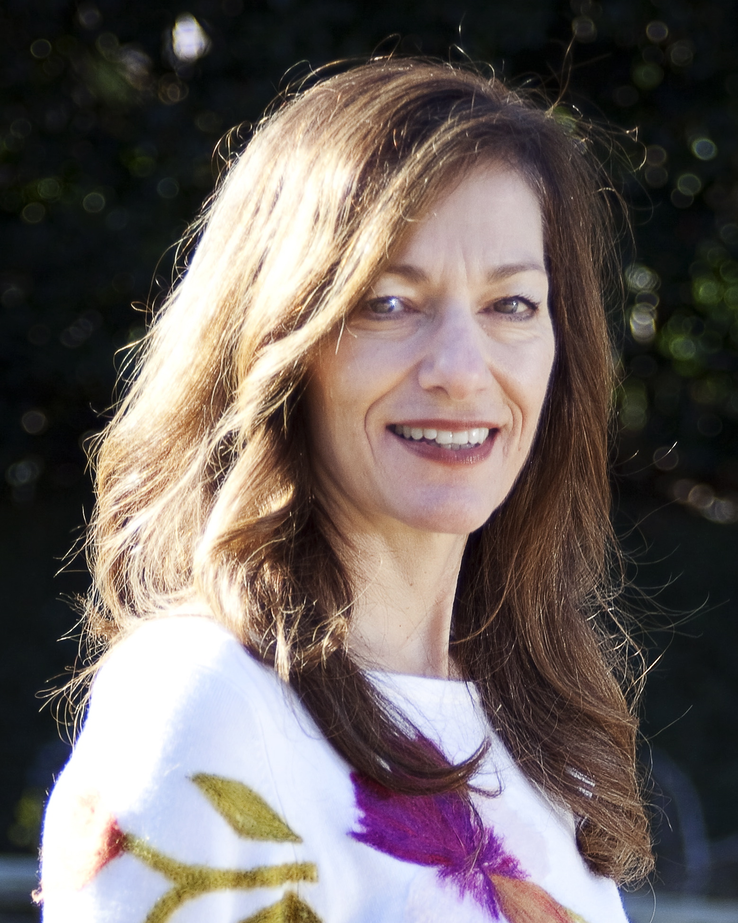
Are you ready to take the next step in your Reiki training? Are you ready for the next level of empowerment? Are you ready for changes in your life?

There are many benefits to taking Reiki II. Reiki II enables you to send Reiki long distance to anyone, anywhere, anytime. You can also program it to continuously send healing energy until it is no longer needed! Reiki II involves the use of symbols which increase its power and help to heal on the mental and emotional levels, as well as physical. The symbols can also be used for clearing spaces and negative energy, protection and purification, and releasing karma and patterns which no longer serve. There are many other uses for the symbols which we’ll cover during class.

When you receive the Reiki II attunement, it will help you to clear your own emotional and mental patterns which are ready to be released. This can take some time and is an ongoing process. It can also open you up to psychic abilities or help you develop ones you already have. Taking Reiki II is a commitment to yourself that you are ready for changes in your life. You will develop an awareness of yourself and your place in this world. You will expand and grow and be challenged. Ultimately, this is very positive, although not always easy. Go into your heart and ask if you’re ready for this at this time.

During class we will discuss the symbols and their uses and I will have you draw them for me from memory. If they're not perfect, don’t worry, you can continue to perfect them afterwards, but do your best to memorize them beforehand. It can take some time to memorize them. The symbols I use can be found in Diane Stein’s book, Essential Reiki, pages 57-58. This is an excellent reference book and I suggest my Reiki I students get this book. I suggest Reiki II students also use this book as a reference and read the section on Reiki II. If you haven’t taken Reiki I from me, read the section on Reiki I as well as Reiki II.

During class we will do a chakra clearing meditation. You will receive your attunement to Reiki II. We will practice sending Reiki long distance so you should bring a stuffed animal, and a picture of two people you want to send healing to. Please get permission from those you intend to send Reiki to. We’ll also be sending healing energy to the earth. We will practice using the symbols on each other as well.

Bring a light lunch. There is a kitchen at the studio. Wear comfortable clothing in layers.

Reiki II Training with Rica Potenz
Rica Potenz is a licensed Massage Therapist, Reiki Master, yoga instructor and musician. Her practice includes many types of massage, CranioSacral Therapy, Lymphatic Drainage Therapy, Neuro Integration, ThetaHealing™, Chakra Balancing, Reiki, Jin Shin Jyutsu, Sound Therapy, belief work and dream interpretation. Her desire is to integrate body, mind and spirit and assist others on their self-healing journey.
Monday
January 26th
9:30am-3:30pm

723 N. Cowan, Lewisville

Investment: $155
deposit of $50 due by
January 19th

call or email to register: 972-333-4488
potenzr@gmail.com
ricapotenz.com

